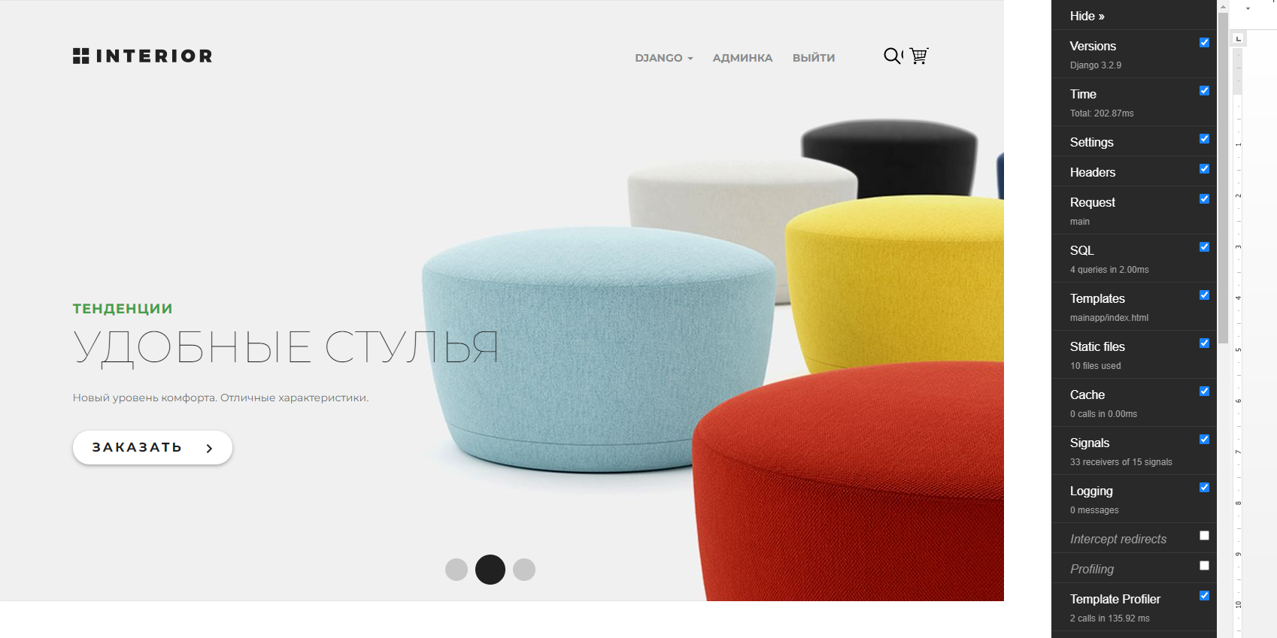

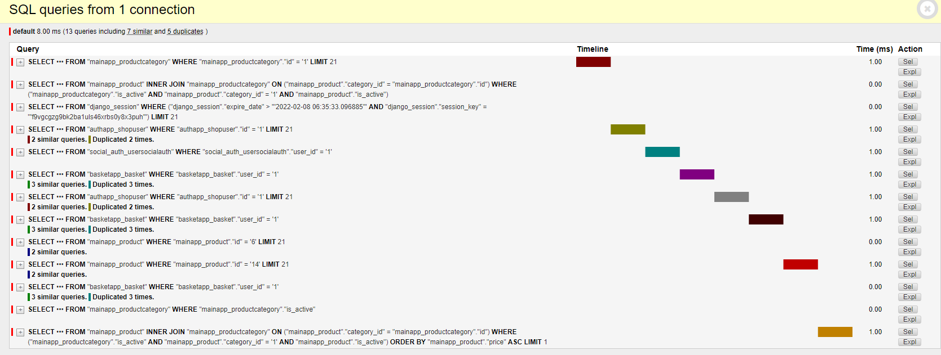

|  |  |  |
| --- | --- | --- |
| Адрес | Число запросов | Число дублей |
| '/' | 9 | 13 |
| '/products/' | 12 | 13 |
| '/products/category/1/' | 13 | 13 |
| '/basket/' | 13 | 16 |
| '/order/' | 4 | 0 |
| '/order/update/4/' | 17 | 84 |
|  |  |  |

